Optimization Report

Index page

The original site submitted showed the following light house report.
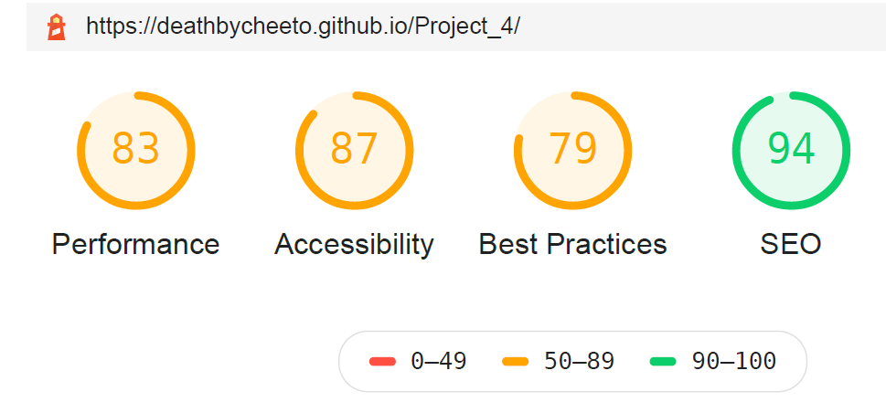
Once we had completed all the changes, the light house report now shows
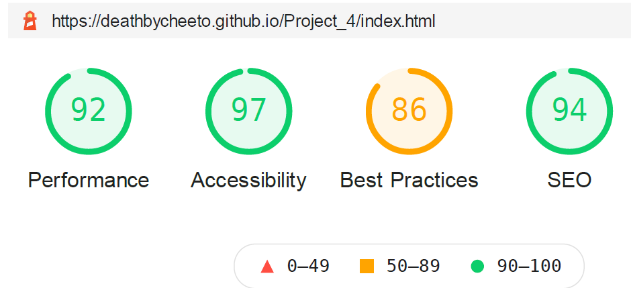

The first thing I started on was Performance
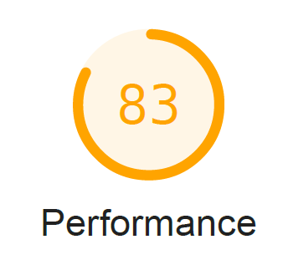

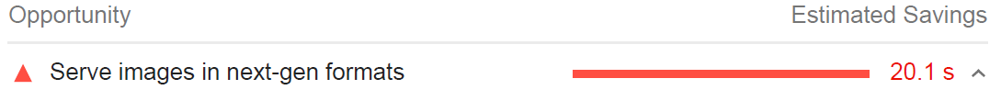
All 3 of these opportunities were corrected by converting image files to WebP images.
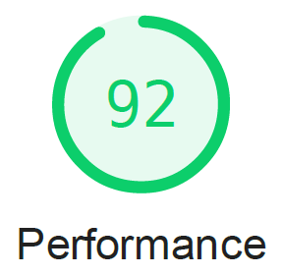
Next I moved on to Accessibility
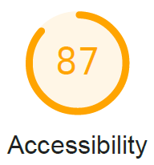

I adjusted the color of the text to contrast with the background color.
I adjust the html language attribute to “en”
I added a title attribute to the Social Media links.

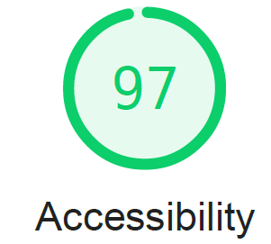

Then I moved onto Best Practices
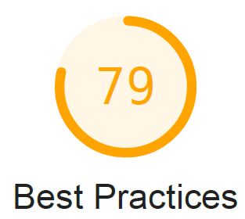

This was resolved after converting images to WebP format.

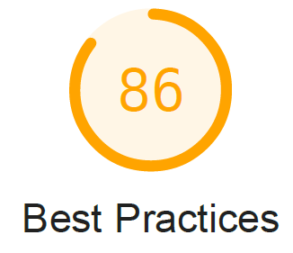

Contact Me Page

The original page2 submitted showed the following light house report.
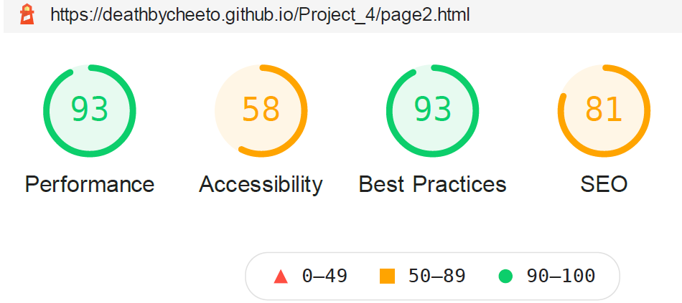
Once we had completed all the changes, the light house report now shows
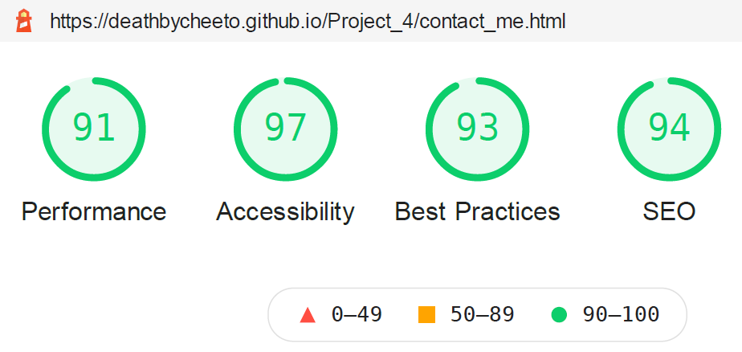
The first thing I started on was Accessibility.
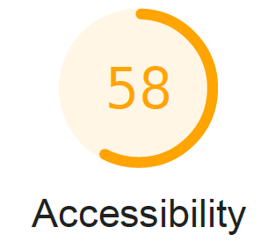

This was resolved when I updated the CSS script for contrast ratio on the index page.

Updated the language to 'en'

Added alt text for images on the page

Associated the labels with the form id

Updated links with titles for social media

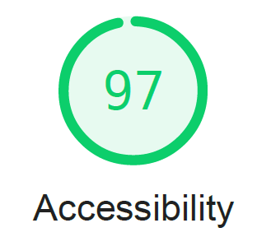

Then I moved onto SEO
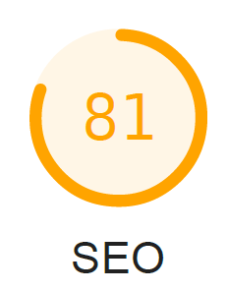
Updated with meta description.

Updated image tags with alt text
